Problem 1: Model Selection

Part 2

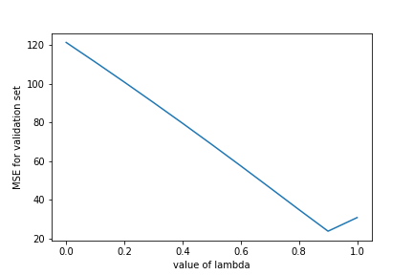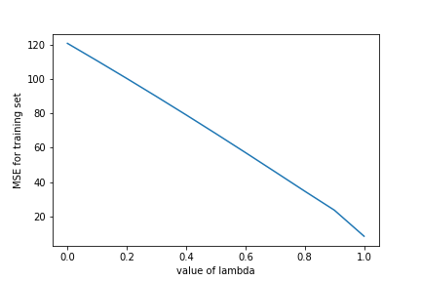For different value of Lambda Training and Validation MSE is shown below:

Fig: MSE of training Data for different Lambda Fig: MSE of training Data for different Lambda

for lambda = 0.9 we get validation error of 23.88 and training error 23.59. We can see for training data lambda = 1 would give the least MSE but it might be overfitting the data as we seem to get a increased MSE in validation set.

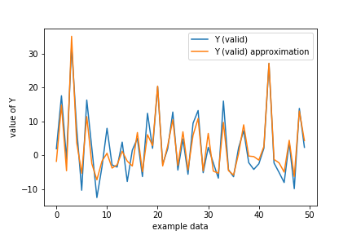As the for high lambda (lambda=0.9) we best fit, which basically means penalizing the higher order terms in W and essentially making the higher degree on polynomial of X to zero. Thus the degree of the source can be assumed to be two or three.

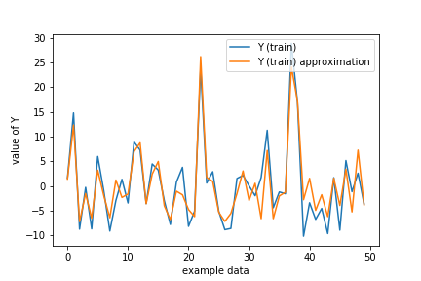

Fig: Visualize Fit of training data for lambda = 0.9 Fig: Visualize Fit of validation data for lambda = 0.9

In both training and validation set, the model seem to fit pretty accurately.